PRESS RELEASE
COMMUNICATIONS AND MEDIA TEAM OF THE 43RD ASEAN SUMMIT 2023
No.97/SP/TKM-ASEAN2023/ENG/9/2023

ASEAN-Japan Comprehensive Partnership Not Merely Ceremonial
Jakarta, 6 September 2023 – The Association of Southeast Asian Nations (ASEAN) and Japan have agreed to form a Strategic Comprehensive Partnership through tangible, mutually beneficial concrete cooperation.
Japan is ASEAN's most active partner and the leading supporter of the ASEAN Outlook on the Indo-Pacific (AOIP) implementation. Support for these two factors can contribute to and realize concrete cooperation that directly benefits the people.
"ASEAN and Japan have agreed to establish a Comprehensive Strategic Partnership beyond ceremonial formalities and small talks," said President Joko “Jokowi” Widodo in his opening remarks at the 26th ASEAN-Japan Summit at the Jakarta Convention Center (JCC), Jakarta, on Wednesday, 6 September 2023.
Strengthening cooperation, continued President Jokowi, has the potential to meet the infrastructure investment needs of ASEAN with an annual cost of US$184 billion.
The cooperation that can be bolstered are the ASEAN Infrastructure Fund and the ASEAN Catalytic Green Finance Facility. Both play a crucial role in supporting green infrastructure and connectivity.
President Jokowi believes that strengthening cooperation between ASEAN and Japan will become even more massive in scale since Japan is geographically close to the ASEAN region.
Both ASEAN and Japan, said President Jokowi, have a shared responsibility to contribute to keeping ASEAN a peaceful, stable, and prosperous region. " This is our home where we grow dan dwell," said the President.
President Jokowi chairs the entire series of meetings on the second day of the 43rd ASEAN Summit which is conducted at the Jakarta Convention Center (JCC).
President Jokowi also chaired the 26th ASEAN-China Summit which was attended by ASEAN Leaders and Prime Minister of China Li Qiang and the 24th ASEAN-Republic of Korea (ROK) Summit which was attended by the President of the Republic of Korea Yoon Suk Yeol.
President Jokowi together with ASEAN Leaders is scheduled to attend the 26th ASEAN Plus Three Summit. The Prime Minister of China, the President of the Republic of Korea, and the Prime Minister of Japan will attend the Summit that will be held in Cendrawasih Room 3, Jakarta Convention Center (JCC), Jakarta
Furthermore, the ASEAN-Canada Summit will be attended by Leaders of ASEAN countries and the Prime Minister of Canada Justin Trudeau. In the evening, President Jokowi and Mrs. Iriana Joko Widodo together with Heads of State/Government and their spouses will attend the Gala Dinner of the 43rd ASEAN Summit.
***
For more information, please contact:
Director General of Public Information and Communications of the Ministry of Communications and Informatics – Usman Kansong (0816785320).
Get more information at http://asean2023.id, https://infopublik.id/kategori/asean-2023, and https://indonesia.go.id/kategori/ragam-asean-2023
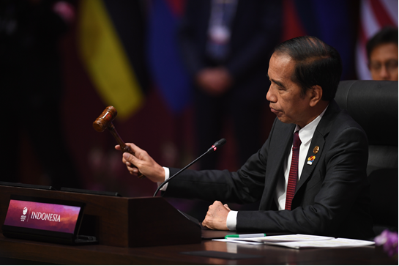
President Joko Widodo chairs the 26th ASEAN-Japan Summit in Jakarta, Wednesday, 6 September 2023. ANTARA PHOTOS/Media Center of 2023 ASEAN Summit /Akbar Nugroho Gumay/foc.

